

HOPE ENTERPRISE UNIVERSEITY COLLEGE

FACULTY OF INFORMATICS

departement of computer science

Jonathan Zeru Delelegn

RCS/311/21

**Assisting Advisor:** Shewatatek Lema

**Lemi Kura Supervisor:** Tesfahun Tilahun

**Submission data:** September 20, 2024

Innovation and Technology Development Office

Internship Project Document

Contents

Acknowledgment ii

Abstract iii

Chapter One: Organizational Related Issues 1

1.1. Background of the Organization 1

1.2 Mission, Vision, and Values of Lemikura ITDO 1

1.3 Objectives of Lemikura ITDO 2

1.4 Structure of the Lemikura ITDO 3

1.5 Main Products and Services of Lemikura ITDO 3

1.6 Computer Science-Related Activities at Lemikura ITDO 4

Chapter 2: Analysis of the Existing System 4

2.1 Software Systems Utilized by the Organization 4

2.2 Network Infrastructure 5

2.3 System Development Tools 6

2.4 Web Systems and Technologies 6

2.5 Hardware Resources 7

2.6 ICT Human Resources 8

2.7 Impact of ICT on the Organization 8

2.8 ICT Policy Framework 9

Chapter 3: Business Process 9

3.1 Managing ICT Needs and Requirements in Organizations 9

3.2 Strategy for Responding to Organizational Software Needs 10

3.3 Users’ Expectations and Satisfaction with ICT Services 11

3.4 Managing End Users’ Requests 11

Chapter 4: Weaknesses of the Existing System 12

4.1 Weaknesses of the Existing WordPress System at ITDO 12

Chapter 5: Proposed Solution 14

5.1 Proposed Solutions for ITDO’s ICT Infrastructure 14

5.1.1 In Terms of Hardware Capacity 14

5.1.2 In Terms of Network Infrastructure 14

5.1.3 Software System Solutions 15

5.2 Lessons Learned During the Process 16

5.3 The Current System we are building for the sub city 16

Reference 20

# Acknowledgment

**በመጀመርያ ለድንግል ማርያም ልጅ ለሆነው እግዚአብሔር ይመስገን።**

Then, I would like to express my heartfelt gratitude for the completion of my internship at the Lemikura Subcity Innovation and Technology Development Office. It's important to recognize those who made this experience possible.

I want to thank God for His guidance and support throughout this endeavor.

I am sincerely grateful to Hope Enterprise University College and the Lemikura Subcity Innovation and Technology Development Office for providing me with the invaluable chance to gain hands-on experience in such a vibrant setting.

I would especially like to acknowledge Mr. Tesfu for his unwavering support and encouragement during my internship. His expertise and mentorship were vital in enriching my learning journey, and I am truly thankful for his guidance.

I also wish to express my appreciation to the entire team at the Lemikura Subcity Innovation and Technology Development Office. Their collaborative and supportive environment played a crucial role in deepening my understanding of innovation and technology.

Thank you all for making this internship a fulfilling and unforgettable experience.

# Abstract

The Lemikura Sub City Innovation and Technology Development Office (ITDO) plays a crucial role in advancing technological innovation and enhancing public service delivery within the sub city. This report aims to provide a comprehensive analysis of the existing ICT system at Lemikura ITDO, highlighting both the strengths and weaknesses of its infrastructure and services. Through a two-month internship, various activities were undertaken, including software and hardware maintenance, network infrastructure development, and user training.

While the office utilizes basic tools such as Microsoft Access for daily reporting and a WordPress-based website for public information, several limitations were identified in the current system, including security vulnerabilities, outdated functionalities, and insufficient scalability. The analysis also revealed that user expectations for reliable, efficient, and user-friendly ICT services are not fully met, leading to dissatisfaction among staff.

To address these challenges, several proposed solutions focus on enhancing the ICT infrastructure and transitioning to modern technologies. Recommendations include investing in private servers, employing Linux-based operating systems, adopting Next.js for web development, and implementing a gradual transition strategy combined with targeted staff training.

The proposed changes aim to ensure that Lemikura ITDO effectively meets its mission of enhancing public services through innovative technologies, ultimately fostering a culture of collaboration and excellence in local governance. This report provides insights into the significance of a robust ICT framework as an enabler of effective service delivery, economic growth, and sustainable development in the digital age.

# Chapter One: Organizational Related Issues

## Background of the Organization

The Lemikura sub city Innovation and Technology Development Office (ITDO) is a governmental entity established with the primary goal of driving technological advancement and fostering innovation within the sub city. Aligned with Ethiopia's broader vision for digital transformation, Lemikura ITDO is integral to local governance by integrating modern technologies to streamline operations and promote sustainable development.

The office’s mandate includes improving digital infrastructure, enhancing public service delivery through technology, and fostering an environment that encourages innovation and entrepreneurship. With a committed team of IT professionals, ITDO is responsible for managing the sub city's technological resources, implementing IT projects, and ensuring the seamless operation of various government systems. Despite challenges such as limited resources and legacy systems, the office remains steadfast in advancing its technological capabilities to meet the evolving needs of the sub city’s population.

## 1.2 Mission, Vision, and Values of Lemikura ITDO

**Mission**  
To empower the Lemikura sub city through the implementation of innovative technologies and digital solutions, enhancing public services, promoting sustainable development, and fostering a culture of innovation that drives economic growth and improved governance.

**Vision**  
To become a leading hub of technological innovation and digital transformation, setting a benchmark for excellence in local governance and public service delivery through cutting-edge technology and innovation.

**Values**

1. **Innovation** – Fostering creativity and new ideas that drive technological advancement and improve public services.
2. **Collaboration** – Working closely with stakeholders in government and the community to create impactful solutions.
3. **Integrity** – Upholding the highest standards of ethics, professionalism, and transparency in all operations.
4. **Sustainability** – Implementing technologies that contribute to long-term environmental protection and resource efficiency.
5. **Excellence** – Striving for continuous improvement in delivering innovative digital solutions for better governance and service delivery.

## 1.3 Objectives of Lemikura ITDO

The Lemikura Subcity Innovation and Technology Development Office (ITDO) operates with clear objectives aimed at improving the technological landscape of the subcity:

1. **Enhance Digital Infrastructure** – To build and maintain a robust and modern digital infrastructure supporting the efficient functioning of public service systems.
2. **Promote Innovation and Technology Adoption** – Fostering the use of cutting-edge technologies to drive economic growth and improve the quality of life for residents.
3. **Improve Public Service Delivery** – Digitizing public services to make them more accessible, transparent, and efficient for citizens.
4. **Support Sustainable Development** – Integrating sustainable practices into technological initiatives, ensuring environmental and resource efficiency.
5. **Enhance Data Management and Security** – Implementing modern data management and cybersecurity measures to safeguard government data and digital services.
6. **Facilitate Collaboration and Partnerships** – Promoting partnerships between government, private sectors, and communities to drive innovation and technological advancement.
7. **Capacity Building and Training** – Providing continuous training for IT staff to keep them up to date with the latest technological trends and best practices.
8. **Promote E-Government Initiatives** – Advancing e-government projects that enhance the efficiency and transparency of interactions between citizens and government entities.

## 1.4 Structure of the Lemikura ITDO

The organizational structure of Lemikura ITDO is designed to ensure efficient management and delivery of technology-driven services and initiatives:

1. **Head of ITDO** – Oversees all departments, providing strategic leadership and ensuring alignment with government policies.
2. **ICT Infrastructure Department** – Responsible for building and maintaining the digital infrastructure, network management, and hardware systems.
3. **Software Development and Integration Department** – Develops, maintains, and integrates software systems that serve various administrative needs.
4. **Network and Security Department** – Manages cybersecurity, ensuring the protection and secure operation of the subcity's IT networks.
5. **Innovation and Research Department** – Focuses on researching emerging technologies and fostering partnerships with startups, academia, and industry.
6. **E-Government Services Department** – Develops and manages e-government services such as online portals and digital transactions.
7. **Training and Development Department** – Provides training to staff and other government employees on the use of new technologies and systems.
8. **Project Management Office (PMO)** – Ensures IT and innovation projects are completed on time and within budget.

## 1.5 Main Products and Services of Lemikura ITDO

1. **Digital Infrastructure Development** – Ensuring reliable network connectivity and maintaining the hardware that supports government services.
2. **Software Development and System Integration** – Developing customized software solutions that meet the administrative needs of the subcity.
3. **E-Government Solutions** – Enabling citizens to access public services online through portals and mobile apps.
4. **Network Security and Data Management** – Providing cybersecurity services and managing large-scale data systems to improve decision-making.
5. **Innovation and Research Services** – Identifying and promoting new opportunities for the adoption of emerging technologies.
6. **Capacity Building and IT Training** – Training government employees on technological systems and best practices.
7. **Project Management for Technological Initiatives** – Managing technology-driven projects to ensure they meet their objectives within budget and timelines.

## 1.6 Computer Science-Related Activities at Lemikura ITDO

During my two-month internship at Lemikura ITDO, I participated in various computer science-related activities that contributed to the office’s technological objectives:

1. **Hardware and Software Maintenance**  
   I assisted in maintaining desktop computers, laptops, servers, and other IT equipment. I also handled software updates, patches, and troubleshooting for essential office applications, ensuring smooth operations.
2. **Building Network Infrastructure**  
   I contributed to the design and implementation of the network infrastructure, including setting up routers, switches, and maintaining network performance for the main and regional branch offices.
3. **Analysis of Incoming Software Systems Documentation**  
   I reviewed and analyzed software systems documentation, ensuring compliance with organizational standards, and identified areas for system improvement.
4. **Project Management**  
   I participated in project management activities, including the implementation of tools to track the progress of various IT infrastructure projects, ensuring timely resource allocation and project completion.
5. **Staff Training in Computer Science-Related Fields**  
   I supported staff training programs, helping regional offices enhance their knowledge and skills in computer science-related fields, particularly in network management and software utilization. Particularly, my mates and I gave a 5 days course about HTML, CSS, JavaScript, and Tailwind.

# Chapter 2: Analysis of the Existing System

## 2.1 Software Systems Utilized by the Organization

During my internship at Lemikura Subcity ITDO, I observed that the organization utilizes a Microsoft Access tool for daily reporting. This tool allows employees to log and report their daily tasks in a structured format. The format includes key fields such as the date, task description, and time spent, ensuring comprehensive tracking of work completed by each employee. While this method is simple, it effectively supports daily operations and reporting.

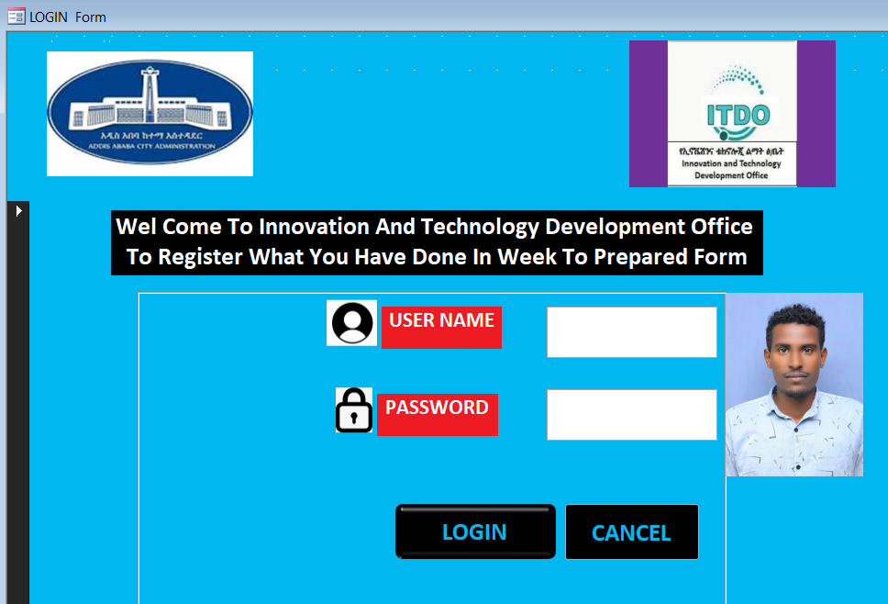

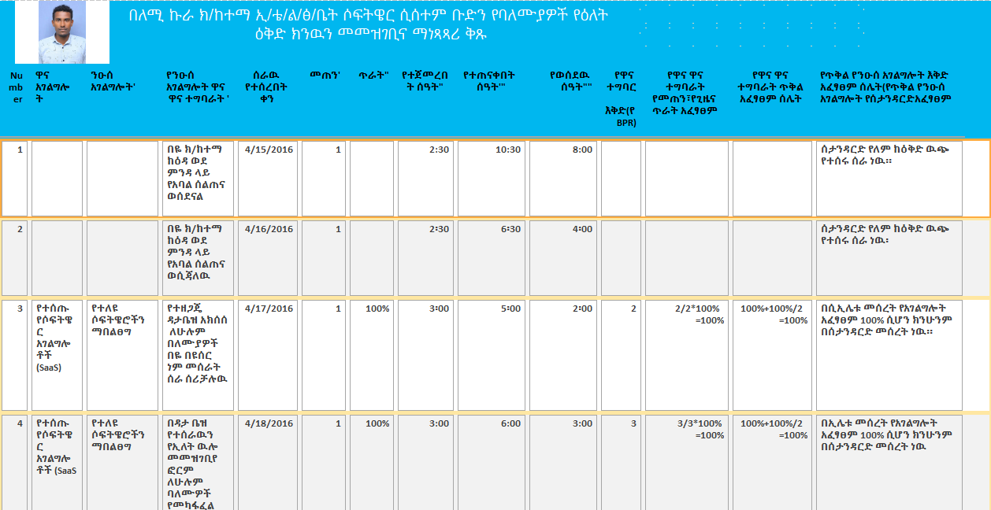

## 2.2 Network Infrastructure

The IT department at Lemikura Subcity ITDO has established a well-structured and secure network infrastructure to support the organization’s digital operations. The network is designed to ensure efficient communication, security, and scalability, which I had the opportunity to observe and learn about during my internship.

* Local Area Network (LAN): The organization maintains a robust LAN that connects departments, offices, and various network devices. The high-speed LAN ensures smooth data exchange and internal operations.
* Wireless Networks (Wi-Fi): Wi-Fi networks are deployed across ITDO offices to facilitate flexibility in accessing the network, particularly for employees using mobile devices and laptops. These wireless networks are secured with encryption protocols to safeguard against unauthorized access.
* Structured Cabling System: The ITDO also employs a well-organized structured cabling system that underpins the physical layer of its network infrastructure. This system connects network devices, ensuring seamless communication, reliability, and ease of maintenance or upgrades.

## 2.3 System Development Tools

During my internship at Lemikura Subcity ITDO, I observed that the organization employs Microsoft Access as a system development tool for daily reporting. Microsoft Access is utilized to log and manage daily tasks, providing a structured format for employees to document their work. The system includes essential fields such as the date, task description, and time spent, which ensures accurate tracking and reporting of daily activities.

This tool serves as a practical solution for the organization’s reporting needs, enabling efficient data entry and retrieval. Although Microsoft Access is a relatively basic database management system, it effectively supports the organization's operations by offering a straightforward interface for task management and reporting. This approach simplifies the tracking of employee productivity and aids in maintaining organized records of daily activities.

## 2.4 Web Systems and Technologies

During my time at Lemikura Subcity ITDO, I observed the organization’s use of web systems and technologies, which enhance both internal and external communication.

* Website: The organization operates a WordPress-based website that serves as a hub for external communication. The website contains essential information about the organization’s services, administrative structure, and updates. The site can be accessed at [www.lemikurasubcity.gov.et](https://www.lemikurasubcity.gov.et).
* Microsoft Access: In addition to its web presence, ITDO utilizes Microsoft Access for internal reporting and record-keeping. This tool is integrated into daily workflows for task tracking and management.

## 2.5 Hardware Resources

During my internship, I had the chance to work with and observe the diverse hardware resources that Lemikura Subcity ITDO utilizes to support its operations. These assets are crucial for the smooth functioning of the office’s IT infrastructure.

1. Computers and Workstations:
   * *Desktop Computers:* High-performance desktops are used for day-to-day tasks. These computers are equipped with the necessary processing power and storage to handle complex workloads.
   * *Laptops:* Laptops are provided to staff members who require mobility, such as field workers and project managers.
   * *Workstations:* Specialized workstations are used to handle resource-intensive tasks.
2. Department Equipment:
   * *Printers, Copiers, and Scanners:* These are available to all staff and support daily office tasks.
   * *Wi-Fi Devices:* Facilitating wireless connectivity across offices.
   * *Projectors, Digital Boards, and Display Screens:* These tools are used for presentations, training sessions, and internal communication.
3. Networking Hardware:
   * *Switches, Routers, and Firewalls:* These ensure secure, reliable network connectivity, both within the organization and externally.
   * *Cabling:* UTP and fiber optic cables provide high-speed connectivity across office buildings.

## 2.6 ICT Human Resources

The ICT team at Lemikura Subcity ITDO is composed of highly skilled professionals who manage the office’s digital infrastructure and software systems. Throughout my internship, I was able to interact with and learn from several members of this team.

1. ICT Director/Manager:  
   The ICT Director is responsible for overseeing the department’s operations and ensuring alignment with the organization’s broader strategic goals. They manage budgets, team members, and compliance with national ICT policies.
2. IT Support Technicians:  
   Technicians provide technical assistance to staff, addressing hardware, software, and network-related issues.
3. Project Managers:  
   Project Managers coordinate IT projects, ensuring that they are delivered on time and within budget.

## 2.7 Impact of ICT on the Organization

ICT has had a transformative impact on the operations and service delivery at Lemikura Subcity ITDO. During my internship, I witnessed firsthand the many ways that ICT has enhanced the organization’s effectiveness.

1. Enhanced Operational Efficiency:  
   ICT tools have streamlined daily operations, automated routine tasks and allowing employees to focus on strategic work. For example, data entry, reporting, and communication processes are now managed digitally, leading to faster decision-making.
2. Improved Communication and Collaboration:  
   Digital communication tools, such as email and intranet systems, have greatly improved internal collaboration. Employees can easily share information and work together across departments, and external communication with stakeholders has become more efficient.
3. Cost Savings:  
   By digitizing processes, ICT has helped reduce operational costs. For example, remote collaboration tools have minimized the need for travel, while automation has reduced manual labor costs.

## 2.8 ICT Policy Framework

The ICT policy at Lemikura Subcity ITDO outlines the principles for the effective management and use of digital resources within the organization. It provides guidelines on data protection, network security, and compliance with national ICT regulations. The policy also promotes innovation, ensuring that the organization's technology strategy aligns with its long-term objectives. During my internship, I had the opportunity to learn about the policy’s critical role in safeguarding data and optimizing ICT services.

# Chapter 3: Business Process

## 3.1 Managing ICT Needs and Requirements in Organizations

During my two-month internship at Lemikura ITDO, I gained insight into how the organization manages its Information and Communication Technology (ICT) needs. I observed that organizations today, including Lemikura ITDO, rely on ICT to drive operational efficiency, streamline workflows, and enhance service delivery. A strategic approach is taken to ensure that ICT resources align with business goals, optimize available resources, and maintain security and compliance standards. Below are the key methods I noted for managing ICT needs:

* Needs Assessment: Lemikura ITDO conducts regular assessments of its ICT requirements based on current operations and future projections. This allows them to identify areas where investments in infrastructure or software are necessary to stay competitive and improve service delivery.
* Coordination with Other Departments: Collaboration between ICT and other departments, such as finance, human resources, and marketing, is crucial. This ensures that technology solutions are tailored to meet specific departmental needs while aligning with the broader ICT strategy.
* Robust Network Infrastructure: Lemikura ITDO ensures its network infrastructure can handle the daily operational demands. This includes maintaining secure local area networks (LANs) and wide area networks (WANs) to provide reliable and high-speed connectivity.
* Custom Software Development: The organization also invests in custom software development to meet its unique operational needs. By tailoring software to specific requirements, Lemikura ITDO enhances its internal processes and service delivery.

Throughout my internship, I saw firsthand how Lemikura ITDO takes a strategic approach to software development by aligning it with the organization's operational goals. The ICT team conducts thorough assessments of existing software, engages end-users for feedback, and develops custom solutions where necessary. This approach ensures that their ICT infrastructure is both efficient and adaptable.

## 3.2 Strategy for Responding to Organizational Software Needs

As part of my internship, I was involved in a strategic assessment aimed at addressing the organization's software requirements. Lemikura ITDO currently relies on older technologies like WordPress, which, while useful, presents certain limitations regarding scalability and performance. To address these issues, I participated in the development of a strategic plan to transition to more modern tools. The strategy included the following steps:

1. Assessment of Current Technologies: We began by analyzing the existing technology stack, particularly WordPress. While effective for basic content management, it was identified as lacking in performance and scalability for larger-scale applications.
2. Research and Identification of Alternatives: We explored newer technologies, with a focus on Next.js—a React-based framework offering server-side rendering (SSR), static site generation (SSG), and enhanced performance. This framework was deemed more suitable for modern web applications requiring complex user interfaces.
3. Justifying the Transition: A cost-benefit analysis was presented to justify the adoption of Next.js. We demonstrated how this modern technology could reduce server load through static site generation, improve user experience, and increase SEO rankings, offering a significant competitive advantage.
4. Gradual Integration Plan: A phased approach was recommended, where WordPress would continue to be used as a headless CMS for content management, while Next.js would handle the front-end, providing a smoother transition without disrupting existing operations.
5. Training and Upskilling: To ensure the ICT team could effectively manage the transition, workshops and training sessions were proposed to upskill the team on React and Next.js, preparing the organization for modern development workflows.
6. Continuous Evaluation and Feedback: Regular evaluations and feedback loops were established to track the performance of the new technology stack and make adjustments as necessary, ensuring that the transition met organizational needs and improved operational efficiency.

## 3.3 Users’ Expectations and Satisfaction with ICT Services

Throughout my internship, I observed the expectations that users within Lemikura ITDO had regarding the ICT services provided. Users expect reliable, efficient, and user-friendly technology solutions that support their day-to-day operations. Their main expectations include:

* Consistent network uptime and reliability.
* Quick resolution of technical issues.
* User-friendly software that enhances productivity.
* Secure data handling and minimal downtime.
* Proactive communication and support from the ICT team.

User satisfaction is closely tied to how well these expectations are not met. During my time at Lemikura ITDO, I noticed that users were not satisfied on how the day-to-day operations were held because everything was paper-based and that held much time that could have been of very help.

## 3.4 Managing End Users’ Requests

Lemikura ITDO has a structured process in place for managing end-user requests and technical support needs. However, during my internship, it became evident that this process is currently not meeting users' expectations. The following issues were observed:

1. **Initial Diagnosis**:  
   Although the ICT team begins by diagnosing the issue to provide an immediate solution, users often report delays in receiving timely assistance. This delay can lead to frustration and extended downtime, impacting their ability to perform daily tasks.
2. **Escalation for Complex Issues**:  
   When issues require specialized expertise, they are escalated to the relevant team or department. Unfortunately, this escalation process is sometimes slow, and users experience prolonged waiting periods before their issues are addressed by the appropriate specialists.
3. **User Communication**:  
   Communication with end-users regarding the status of their requests is inconsistent. Users frequently report a lack of regular updates, leading to uncertainty about the progress of their requests and the estimated time for resolution. This lack of transparency contributes to user dissatisfaction.
4. **Post-resolution Feedback**:  
   After an issue is resolved, users are typically asked for feedback. However, this feedback is not always effectively utilized to improve the support process. As a result, recurring issues and user complaints persist, indicating that the feedback loop is not adequately addressing areas for improvement.

# Chapter 4: Weaknesses of the Existing System

## 4.1 Weaknesses of the Existing WordPress System at ITDO

During my internship at ITDO, I had the opportunity to critically evaluate the organization's current Information and Communication Technology (ICT) infrastructure, with particular focus on its WordPress-based website. Below are the key weaknesses I identified:

1. Security Vulnerabilities:  
   The current WordPress website lacks essential security measures, making it vulnerable to hacking, malware, and cyber threats. Without SSL certificates, firewalls, and regular updates, the site is at risk of being compromised.
2. Limited Functionality:  
   The existing system fails to meet the evolving needs of the organization, particularly in terms of user interaction, automation, and system integration. This limits the website’s ability to support ITDO’s operational and service-oriented goals.
3. Outdated Plugins and Themes:  
   The website relies on outdated plugins and themes, which introduces compatibility issues, slower performance, and higher vulnerability to security breaches.
4. Poor User Experience:  
   The current design of the website does not prioritize user engagement or ease of navigation. Users face slow loading times and cluttered layouts, which diminish the overall experience.
5. Lack of Customization:  
   The website, built on a standard WordPress template, offers limited flexibility to meet ITDO’s specific needs. Customization for unique organizational processes is difficult to implement.
6. No Data Protection Measures:  
   There is a lack of robust data protection mechanisms, increasing the risk of sensitive organizational and user data being compromised. Encryption and secure data storage are lacking.
7. Not Mobile-Responsive:  
   The website is not fully optimized for mobile use, making it difficult for visitors accessing the site via smartphones or tablets, which negatively impacts accessibility and engagement.
8. No Scalability:  
   The existing system lacks the capacity to grow or accommodate additional features without undergoing a major overhaul. This hinders ITDO’s ability to expand its online presence and services.
9. Poor SEO Performance:  
   The website has not been optimized for search engines, making it difficult to rank well in search results. This reduces visibility and limits the organization’s reach to a broader audience.
10. Inconsistent Updates and Maintenance:  
    The website does not receive consistent updates or maintenance, leading to performance issues, potential security holes, and occasional downtime.

# Chapter 5: Proposed Solution

## 5.1 Proposed Solutions for ITDO’s ICT Infrastructure

During my internship, I worked closely with ITDO's ICT team to identify potential solutions to address the limitations of their existing system. Based on my observations, I propose the following strategies:

### 5.1.1 In Terms of Hardware Capacity

The current server infrastructure used by ITDO is insufficient for its growing needs. I propose the following improvements:

1. Private Servers:  
   ITDO should consider investing in or renting private servers to host their websites and databases. This will grant them better control over their infrastructure, higher security, and the flexibility to manage their data effectively.
2. Linux or Ubuntu Operating Systems:  
   Utilizing stable, secure, and flexible operating systems like Linux or Ubuntu will provide robust support for the servers. Nginx for web server management and YUM for package management would further streamline operations.

### 5.1.2 In Terms of Network Infrastructure

For the organization to modernize its network infrastructure and ensure efficiency:

1. Reliable Internet and Local Networking:  
   ITDO should focus on establishing a reliable internet connection and local network (LAN) that allows employees to securely access servers and databases. This can be achieved by installing routers and switches for seamless data sharing between systems.
2. Firewalls and VPNs:  
   Implementing firewalls and network monitoring tools will enhance security and ensure that sensitive data is protected. Virtual Private Networks (VPNs) could also be introduced to enable secure remote access for employees working offsite.
3. Redundant Systems:  
   ITDO should consider setting up failover systems and backup internet connections to guarantee business continuity in case of network outages.

### 5.1.3 Software System Solutions

To address the limitations of the existing WordPress-based website, I propose a shift to a more modern and scalable framework.

1. Adopting Next.js:  
   Next.js, a React-based framework, offers superior performance through server-side rendering (SSR) and static site generation (SSG). This transition will lead to faster load times, better SEO, and improved user experience, making it a more suitable solution for ITDO’s future needs.
2. Headless CMS Approach:  
   Instead of completely abandoning WordPress, I recommend adopting a headless CMS approach, where WordPress continues to manage backend content while Next.js powers the front end. This provides the best of both worlds: modern UI and performance without sacrificing content management efficiency.
3. Improved Scalability and Customization:  
   Next.js will allow for easier integration with APIs and databases, offering ITDO flexibility for future growth. This will enable the development of custom features tailored to the organization's specific requirements.
4. Performance Boost and Cost Efficiency:  
   The use of static site generation (SSG) will significantly reduce server load, enhancing website performance while also reducing operational costs.
5. Gradual Transition:  
   To minimize operational disruptions, I suggest a phased approach to transitioning from WordPress to Next.js, enabling smooth adoption while ensuring continued website functionality.
6. Training and Upskilling:  
   I propose providing the development team with targeted training on Next.js and React to equip them with the skills needed to maintain and expand the new system effectively.

## 5.2 Lessons Learned During the Process

Throughout my internship at ITDO, I had the opportunity to expand my knowledge and technical expertise, particularly in the following areas:

1. Back-End Development:  
   While I initially had a strong understanding of front-end development using React and Next.js, I gained valuable experience in back-end development. I learned how to design and build databases and API endpoints, which were crucial for server-hosted applications.
2. Server Management:  
   I acquired skills in managing server infrastructure and deploying modern web applications, which deepened my understanding of how to create scalable, secure, and efficient ICT solutions for organizations.
3. ICT Strategy Development:  
   My role in evaluating the existing system and proposing an ICT strategy allowed me to experience the importance of aligning technological decisions with organizational goals, ensuring that all improvements directly support business objectives.

## 

## 5.3 The Current System we are building for the sub city

Since the database and also the api endpoints have, all been completed using the NextJs, prisma, and mysql we have reached the end of integrating them to the front-end of the website and also the dashboard so that the admin can post news, vacancy, event, and the administration information of the sub-city. The schema for the api looks like the following:

One thing to heads up here is that the attributes for the entities are still being refined and is not the final product!

This Prisma schema defines a relational database structure for managing users, locations, events, vacancies, news, and roles for our system. The schema is designed to support a multi-functional platform where users can interact with various entities like news, events, and job vacancies, all while being managed under different roles and categories.

**Key Models**

1. **User**
   * **Attributes:** Includes personal details such as name, email, phone, profile image, bio, and role.
   * **Relationships:**
     + Linked to Location for geographical data.
     + Connected to UserRole for role-based access.
     + Can create multiple Vacancies, Events, and News.
2. **Category**
   * **Attributes:** Defines categories with a name, description, image, and video.
   * **Relationships:**
     + Associated with News and Events to categorize them.
3. **Location**
   * **Attributes:** Contains geographical details including city, country, latitude, and longitude.
   * **Relationships:**
     + Linked to User, Event, and Vacancy models for location-based organization.
4. **News**
   * **Attributes:** Includes content-related fields like title, description, image, video, and audio, along with flags like isBreaking.
   * **Relationships:**
     + Tied to a Category and created by a User.
5. **Event**
   * **Attributes:** Captures event-specific data such as title, description, date, and media.
   * **Relationships:**
     + Associated with Location, Category, and the User who created the event.
6. **JobType**
   * **Attributes:** Describes job types with a title and detailed description.
   * **Relationships:**
     + Connected to Vacancy, defining the type of job for each vacancy.
7. **Vacancy**
   * **Attributes:** Contains job posting details like title, description, salary, and application deadline.
   * **Relationships:**
     + Linked to Location, Category, and JobType.
     + Created by a User.
8. **UserRole**
   * **Attributes:** Defines roles within the system, with a title and description.
   * **Relationships:**
     + Associated with multiple Users, determining their role in the system.

**Key Points**

* **Modular Relationships:** Each model is interconnected, allowing for dynamic relationships between users, roles, events, and more.
* **Scalable Design:** The schema is designed to support scalability, with clear separation of concerns through models like Location, Category, and UserRole.
* **Role-Based Access:** UserRole model ensures role-based access and control across the platform, enhancing security and organization.

Currently the website is being tested and is approved to be hosted by the Sub city, but temporarily you can check the prototype on the following url hosted on the free hosting platform Vercel. https://lemi-temp.vercel.app

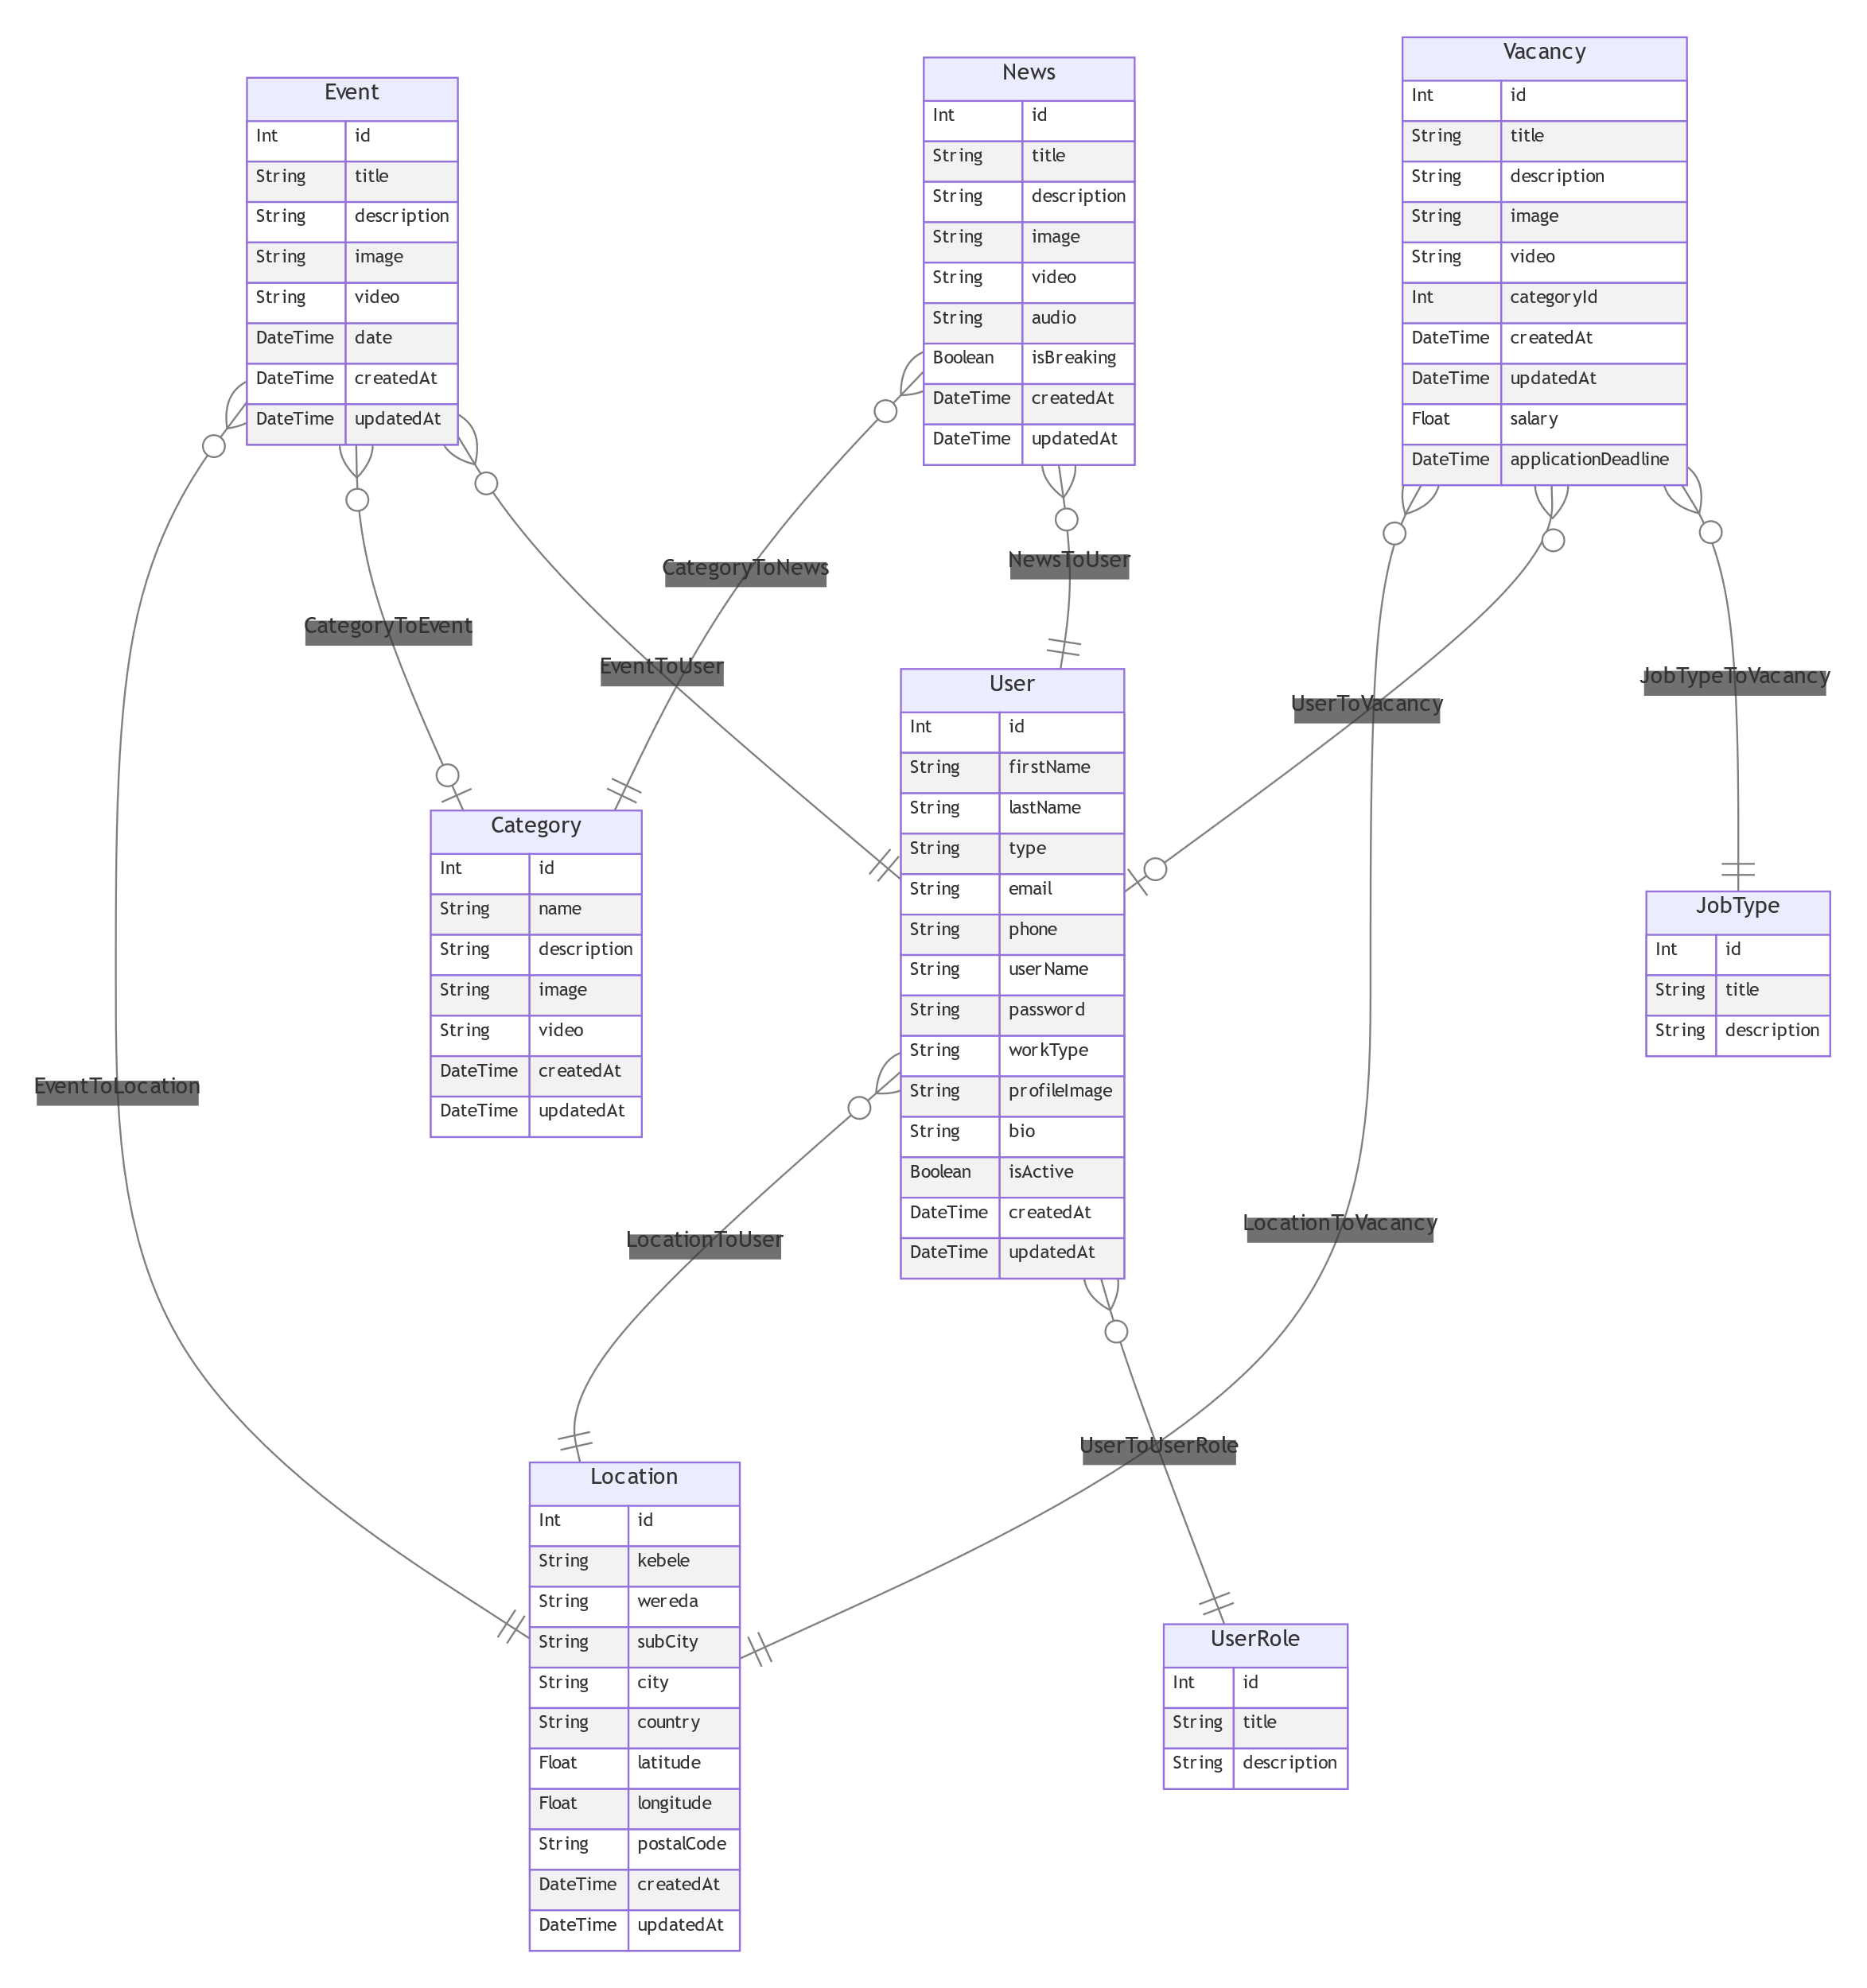

# Reference

Lemi Kura Sub City Official Website, <https://www.lemikurasubcity.gov.et>.

Lemi Kura Sub City organizational documents that are against the companies policy to officiate them.